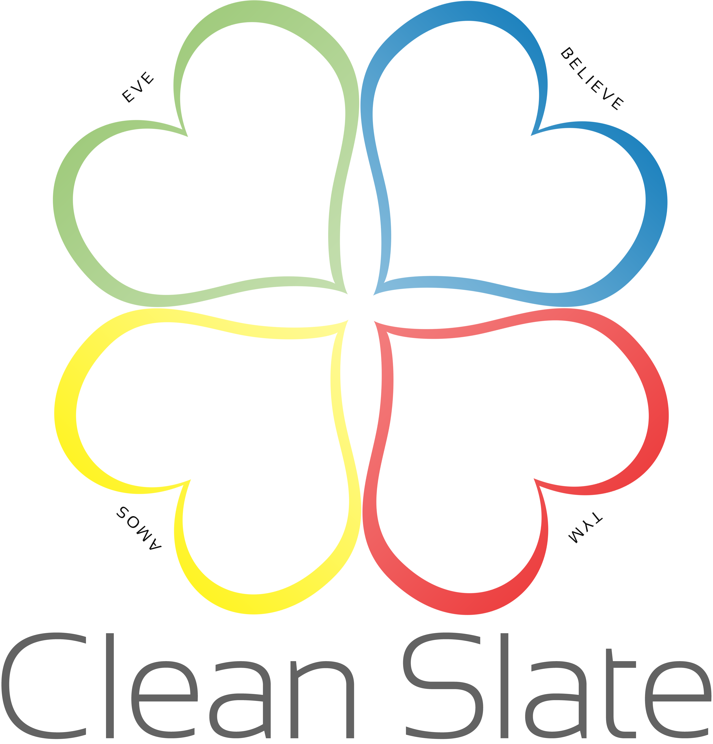  Impact Report 2019-20  Registered Charity number: 1132281 | Abuse effects everyone  Compiled by Nadia Brown  Adopted by Board of Trustees Date: 17/11/2020 and Signed by: Anji Hall

Mission
The purpose of Clean Slate is to provide long term emotional support for male and female survivors of abuse in the UK, particularly in Cherwell and wider Oxfordshire. We aim to encourage individuals to explore their own mental health needs and adopt positive coping strategies for long term recovery. To support Men, Women and their families who have been victim too or witnessed domestic, sexual, mental, emotional, and financial abuse.

Structure, governance, and management
Type of governing document: | Constitution Adopted on the 25th September 2009 Amended on the 13th January 2014
How the charity is constituted | Unincorporated
Trustee selection methods | Trustees are appointed or reappointed annually at the Annual General Meeting held in February
Legal Entity | Clean Slate is a registered charity with a Trustee board consisting of trustees from all walks of life. We currently have 7 trustees who meet quarterly.
Additional Governance issues  Structure:  Policies and procedures:  Relationships with any related parties: | The Board Trustees are responsible for the integral running of Clean Slate, and to ensure that services given are ethically and morally delivered. All disputes and complaints are dealt with by the Trustees if major or complex. This is made up of a group of named persons who are held accountable to the charity and the Charities Commission.  Project Manager is a paid member of staff who is supported by 3 part-time coordinators, they oversee the general running of the whole service. They are accountable to the Board of Trustees. The Project Manager seek the views of users, the staff and volunteers in deciding the activities we provide.  There is a safeguarding policy in place.  Criminal Records Bureau checks are carried out prior to commencement of employment or trusteeship and checks are carried out again in line with statutory requirements.  Clean Slate is affiliated with The Survivors Trust. Members of the BACP, we have a long running affiliation with Dorchester Living who allow us to run our services from their premises free of charge.  All trustees give their time voluntarily and received no remuneration or other benefits.
Location | Our Head Office is based in Upper Heyford at The Chapel, Building 572 Brice Road, Upper Heyford, Oxon, OX25 5TE

Overview of Charity
Approach
At Clean Slate we aim to provide an eclectic approach. (Different approaches appropriate to the client’s needs. This is based on the theory that there is no proof that any one theoretical approach works better than all others for a specific problem), we have identified these needs during the last 11 years of providing the service.
We are currently the only service in Oxfordshire that provides long-term counselling to survivors of abuse. As a result of this we have built up working relationships with local professionals. We accept referrals from doctors, mental health teams, the police, social services as well as self-referrals.
Each client has an initial assessment. A personal pathway is drawn up, which sets out achievable goals, and this is then continually assessed throughout the process.
Counselling is provided alongside enrollment on certain programs depending on the specific needs of our client. These programs often deal with specific problems but will broadly fit into four categories:
- Improving health and wellbeing.
- Improving integration into society.
- Increasing personal safety and perception of safety.
- Improving experience of the criminal justice system.
We continually monitor user satisfaction and outcomes. We also follow the Charity evaluation monitoring programme. This allows us to review our current procedures, adapt them and evolve new ones.
Issues
These psychological problems are often deeply ingrained. Currently the NHS will offer a set number of free counselling appointments and these often only scratch the surface. There is a huge demand for free longer-term support.
Dealing with the mental health side of the problem is vital. However, this will take time and there is a real need for these people to gain practical skills to deal with certain situations they often find themselves in. For example, one of our clients was trapped in an abusive relationship. The counselling and support we provided could help her cope but it was the skills, confidence and knowledge about how to leave a relationship like this that made the biggest impact in her life.
Capabilities
The team at Clean Slate is hugely passionate about helping our clients. Many have lived experience so can understand and empathise with what our clients have gone and are going through.
Objectives
- The relief of mental and emotional stress caused by the effects of abuse either physical, mental, sexual or emotional abuse and historic by the provision of counselling and support.
- To relieve the mental and emotional stress of person’s resident in Oxfordshire suffering from abuse by the provision of counselling and support.
- To relieve the effects of Domestic Abuse by the provision of Counselling, Support, and peer group provision.
- To relieve the mental and emotional stress of male victims by provision of counselling and support.
- To work with other organisation through information sharing and joint working practices for the benefit of vulnerable clients.
- To promote the awareness of the effects of abuse on families, communities, and individuals.
- To safeguard all clients regardless of age, sexuality, culture, disability, and background.
Team
Paid Staff
1 x Project Manager (30 hours a week)
1 x Part-time Male Support Coordinator (8 hours a week)
1 x Part-time Emotional Support Administrator (12 hours a week)
1 x Part-time Volunteer Development Administrator (12 hours per week)
Volunteers
5 x Qualified Counsellors
8 x Trainee Counsellors
3 x Peer Support
1 x Administrators

2019-20 - Achievements
Provided 160 hours to the TST Helpline

24
New volunteers joined the team

211
initial assessments

932 counselling hours provided

Trained 2 new freedom programme facilitators

44
Participants of the Freedom Programme

Created 2 part-time job vacancies for 2 volunteers

We have gone from face to face sessions to virtual due to COVID-19

PAPER FREE
We are finalists in the Cherwell Innovation Awards

Plans for 2020-21
- Change charity to a CIO
- Increase number of freedom programmes facilitated
- Have our own MHFA facilitator
- Develop our volunteer development programme
- Invest in a client management system
- Secure funding for administrators posts.
- We aim to improve skills in social media; media training; management and current counselling practices.

Risk Factors for 2020-21
- The nature of coronavirus is changing daily, so we need to be flexible in our working
- Clients wanting face to face support will depend on suitable COVID-19 friendly accommodation becoming available.
- The needs of clients and their mental health due to COVID-19, could mean us needing to provide more support
- Funding is difficult to acquire due to the nature of the cause and lack of understanding and public perception. Completing funding application forms is time consuming with no guarantee of success. Many funders prefer to fund new projects rather than to help to sustain ongoing projects.
- Fundraising is time consuming and isn’t always that lucrative. At times the initial outlay fails to be met. It would require a dedicated fundraiser with experience and commitment.
- Premises, for the last 11 years we have been fortunate to have rent free accommodation, heating and lighting, in the future we will need to raise funds for rent and utilities on top of our core costs. We are currently working on a long-term strategy which we envisage would mean a move in premises as we are close to outgrowing the space, we have available to us.
- Volunteers, our charity is dependent on volunteers. So, the wellbeing of our volunteers is vital. i.e. managing workloads and sickness
- Recruiting, training and retaining volunteers and staff is ongoing and is being addressed in our long-term strategy.

Summary
This year has been a challenging year however through hard work, commitment, and perseverance of our volunteers and staff we have met with these challenges very well.
As always sustainability of the charity is always a priority and we started the year asking clients to make contributions/donations towards their sessions. The clients that could afford this did and continue to do so.

Nobody could have prepared us for a pandemic and there were times when we were unsure if we would make it out still standing. However again with hard work, commitment, and perseverance from our volunteers and staff we find ourselves in a better situation than we could have imagined.

We had to adapt the service and learn new ways to work, which we all have done well.

There has been an impact on the service, this year to date we have seen our referrals increase by 100%. The referrals have come from Talking space, Family solutions, OMHT, and GP’s, the police as well as self- referrals.
There is no doubt that the lack of counselling provision in the area alongside the impact of COVID-19 on people’s mental health has caused the hike in referrals to our service. With the continued pandemic and restrictions in place there is no doubt that the referrals will keep on coming as other services continue to pass clients on to us.
We have had to change from a face to face service to an online/phone counselling & Support service which has had its own problems, with internet security, GDPR, phone connection, privacy as well as the fact that when people are seen face to face they are coming to a safe space, whereas by phone or skype they are still in their own home. We have worked hard at putting all the safeguarding in place to protect clients, and we are striving to enable as many people as possible to access our services.

Financially we have been able to access funding that would not have been available if there wasn’t a pandemic and this has in turn enabled us to strengthen the sustainability of our charity going forward as well as taking on our first paid contract from Survivors Trust.

We have seen an increase in volunteers wanting to support the charity which again has made a positive impact.

I feel that we have faced the challenges of 2020 well and it has enabled us to look at the service in a whole new way. Specifically, in regard to how we provide support. There are some changes to be made however I am confident that with hard work, commitment and perseverance as a team we can grow even stronger.

Financial Overview for year end 2019-20
Income: Expenditure:
Contributions in Kind £27,221 Contribution in Kind £27,221
Grants £20,750 Salaries £41,926
Parish councils £3,725 Communications £926
Charitable trusts £9,810 Audits/Insurances: £564
Fundraising £2,832 Rent: £225
Donations £5,265 Stationary/printing: £818
Client contributions £7,821 Volunteer Development £2,925
Contracts £10,712
Gift Aid £4,646
Furlough £384
Total £93,166 Total £74,261

Supported by:

Souter Charitable Trust
Meadow Trust
Cooper Charitable Trust
Doris Field
Bartlett Taylor Trust
Pye Charitable Trust
Groundwork
Greggs Foundation
Leeds Building Society
Magdalen Trust
Foyle Foundation
CAF - Warburtons
Oxfordshire Community Foundation
Groundwork-Tesco’s
Good Exchange
Lottery
Groundwork - Tesco
Cherwell Priority Fund

Parish Councils

Benson
Sonning Common
Aston, Cote, Shifford & Chimney
Milton Under Wychwood
Caversfield
Appleton with Easton
Great Milton
Horley
Tetsworth
Eynsham
Ambrosden
Wallingford Town Council
Kennington
Cumnor
Wheatley
Abingdon
Drayton Abingdon
Northleigh

